|  |  |  |  |  |  |
| --- | --- | --- | --- | --- | --- |
| **Key Vocabulary** | | | | | |
| **Flexibility** – this is the **range of movemen**t possible at a joint. It allows performers to reach, stretch and move their joints. | **Lateral jumps** - a type of exercise that can enhance your explosive strength, coordination, and power. | | **Changeover -** in [relay](https://dictionary.cambridge.org/dictionary/english/relay) [races](https://dictionary.cambridge.org/dictionary/english/race) where each [person](https://dictionary.cambridge.org/dictionary/english/person) in a [team](https://dictionary.cambridge.org/dictionary/english/team) [runs](https://dictionary.cambridge.org/dictionary/english/run) and each [member](https://dictionary.cambridge.org/dictionary/english/member) of the [team](https://dictionary.cambridge.org/dictionary/english/team) [hands](https://dictionary.cambridge.org/dictionary/english/hand) the [baton](https://dictionary.cambridge.org/dictionary/english/baton) to the next. | | **Technique** - a skill or ability in a particular field. |
| **What you need to be successful?** | | | | | |
| **How to develop your sprinting technique** | | **How to develop the correct technique for a chest pass** | | **How to effectively perform a changeover in a relay race** | |
| * Stand in a space with your feet shoulder-width apart and your knees slightly bent. * Keep your feet on the ground and start pumping your arms. * Swing arms from your shoulders, bending at the elbows. * Keep your hands relaxed. * Gradually build up speed so that you are pumping your arms as fast as you can. | | * Step towards the target * Apply force and push the ball/object forward toward the target and release. * Follow through by extending your arms (and thumbs facing down). | | * Extend your hand and keep your hand steady as you approach your team member. * Aim for the middle of the passing hand. * Slow a little on the approach to the passing hand. * The outgoing runner should avoid looking behind or grabbing at the baton during the pass. | |
| **Building Blocks to Success** | | | | | |

**Pictures of Skills**

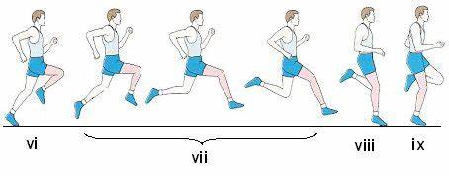

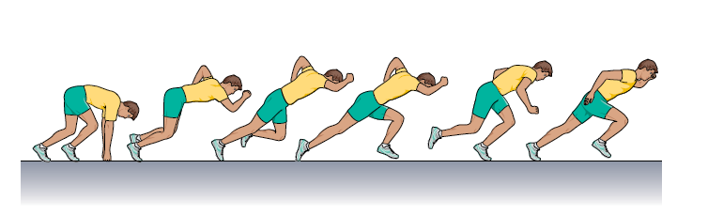

**Running Technique**

**Starting Technique Technique**

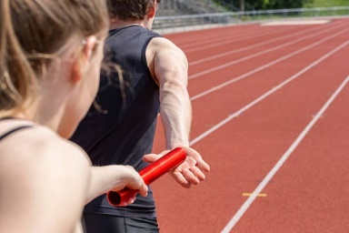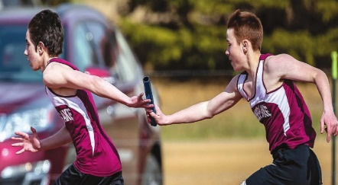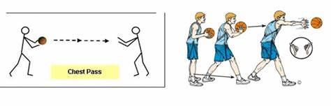

**Chest Pass**

**Changeover Technique**